Results:

Experimental setup:

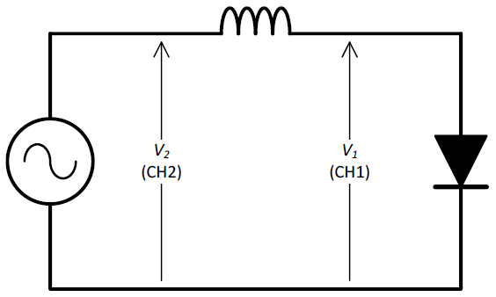

Figure : circuit diagram for Chaotic Oscillator, reproduced from University of Southampton, X3 laboratory experiment [2]

Using a function generator to provide V2, set to 142 kHz sinusoid wave.

Using an oscilloscope to monitor the bifurcation point and measure the voltages of V1 and V2.

Repeat the measurements 5 times.

Use formula: $δ=\frac{V_{2}-V_{1}}{V_{3}-V_{2}}$ [1] to calculate the Feigenbaum constant.

|  |  |  |  |  |  |  |  |
| --- | --- | --- | --- | --- | --- | --- | --- |
| No. | 1->2 V1osc/V | 1->2 V1func/V | 2->4 V2osc/V | 2->4 V2func/V | 4->8 V3osc/V | 4->8 V3func/V | Result |
| 1 | 1.68 | 1.48 | 2.16 | 1.97 | 2.28 | 2.1 | 4 |
| 2 | 1.64 | 1.48 | 2.12 | 1.97 | 2.28 | 2.1 | 3 |
| 3 | 1.68 | 1.48 | 2.16 | 1.97 | 2.24 | 2.1 | 6 |
| 4 | 1.64 | 1.48 | 2.16 | 1.97 | 2.24 | 2.1 | 6.5 |
| 5 | 1.68 | 1.48 | 2.16 | 1.97 | 2.28 | 2.1 | 4 |
| Standard value |  |  |  |  |  |  | 4.669 |

Vnosc: Peak-to-peak voltage measured by oscilloscope

Table 2: measurements and results

Vnfunc: Peak-to-peak voltage set by function generator

Result: The Feigenbaum constant calculated using voltage measured by oscilloscope

Standard value: The Feigenbaum constant given by Wikipedia.org. [1]

Error calculation:

Error rate of oscilloscope: ± (3% × reading + 0.1 div + 1 mV) [3]

Precision of function generator pk-pk voltage: 0.01V for V1 and V2, 0.1V for V3.

So total error of V1 is 3.74%, V2 is 3.55%, V3 is 7.81%.

By formula $δ=\frac{V_{2}-V_{1}}{V_{3}-V_{2}}$ [1], error percentage of results by adding errors together is 18.65%.

Discussion:

The 5 results got from the experiment are: 4, 3, 6, 6.5 and 4.

Calculate the mean result: 4.7

Standard result got from Wikipedia.org is 4.669 [1].

Some possible error sources:

1. Instruments, totally 18.65%
2. Percentage error of varies of results, (6.5 - 3) / 2 / 4.7 * 100% = 37.2%
3. Human error

Apply error percentage of 18.65%, the actual result range can be from 3.82 to 5.58.

The standard result 4.669 [1] is in the range, so the mean result 4.7 is acceptable.

But, the error percentage of the result is quite big, so the result is not accurate and reliable at all.